THE TITLE OF THE PAPER (Title En)

**MIRCEA POPA** - Lecturer, PhD, Technical University of Civil Engineering, Faculty of Building Services,   
e-mail: (affiliate institution address only will be published) (Author’s name)

**Abstract:** In the summary, the representative aspects of the paper will be mentioned – minimum 8 rows. It will be written in regular (size 10 ), paragraph left-right, 1,2 cm (ABSTRACT)

**Keywords:** 4-5 representative words for paper, not included in the paper title(Keywords)

1. Introduction (Chapter)

The title “Introduction” will be numbered, written in small capitals (size 12) and bolded.

In the introduction of the article, the present state of the reaserchers in the specified domain will be mentioned (by quoting the corresponding bibliography) and the objectives of the paper will be declared.

The paper will be of 6 pages at least, the font used being TNR, size 12, the paragraphs being separated from one another with one line of size 6. (Normal text).

2. Paper content (the title of the first chapter) (Chapter)

The names of the chapters will be numbered if necessary, written in small capitals (size 12), bolded, centered left.

The presentation will be short and concise, and the symbols used will be defined in a symbol list (only if necessary). The International System of Measurement Units will be used. Descriptions of machineries and installations are not reccommended.

2.1. Subchapter Subchapter (1.1)

2.1.1. Subsubchapter Subsubchapter (1.2.1)

3. Paper content (the title of the second chapter) (Chapter)

Equations. Equations are to be numbered with an indented line at right and written with the help of the equations-editor : Settings – size : 12, 10, 7, 18, 12, style: italic variables,LG Greek italic.

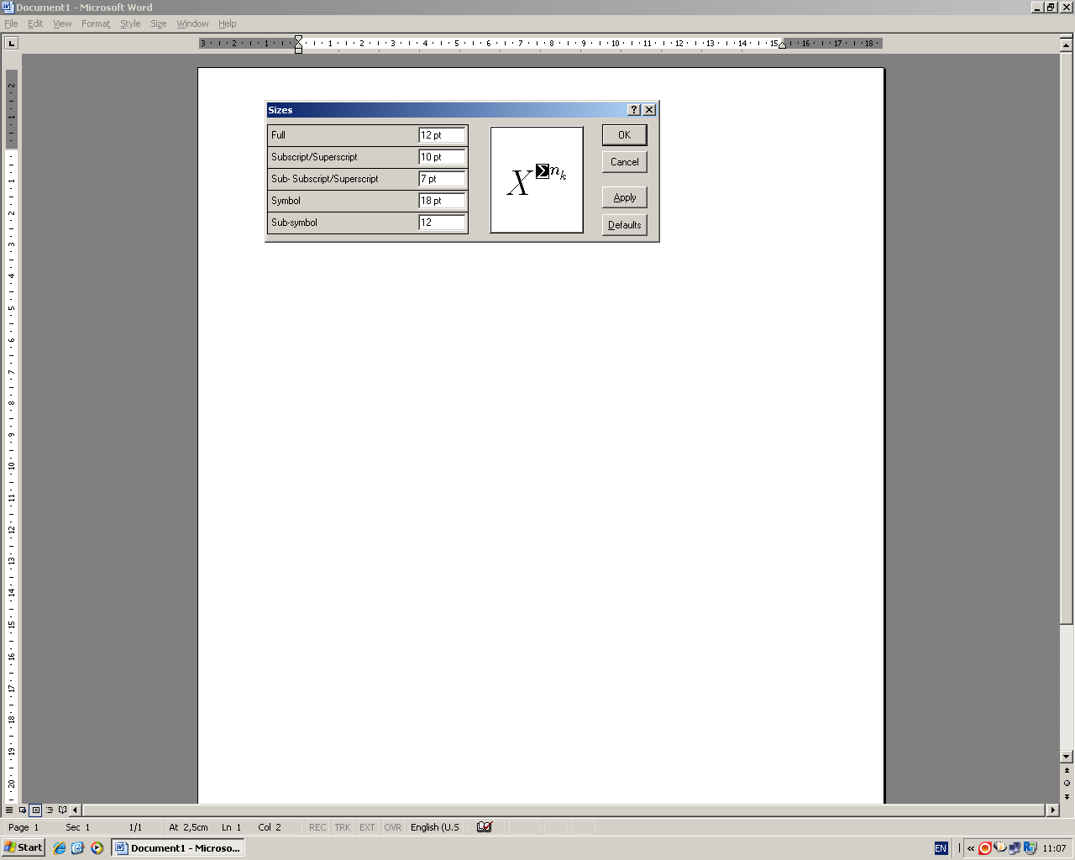

(Equations) (1)

**Tables.** Tables are to be written in size 10. The title of the table is to be centered, bolded and its numerotation written in italics (size 10), centered right.

Table 1 (NUMBER OF THE TABLE)

Melting points and basic analysis (TABLE TITLE)

|  |  |  |  |  |
| --- | --- | --- | --- | --- |
| Compounds | Mp(0C) | Chemical formula | N (%) | |
| Calculated | Resulted |
| 3A | 178 | C29H34N2O | 6,57 | 3A |
| 3B | 264 | C29H33N3O3 | 8,92 | 3B |
| 3C | 232 | C29H32N4O5 | 10,85 | 3C |
| 5A | 185 | C29H34N2O | 6,56 | 5A |
| 5B | 242 | C29H33N3O3 | 8,92 | 5B |
| 5C | 245 | C29H32N4O5 | 10,85 | 5C |

**Figures.** Figures are to be placed centered, if they are big and complex enough. If not, they can be put on two columns or wrapped in the text, towards the exterior of the page (right for an even page and left for an uneven page). The legend is to be centered under the figure, in size 10.



Fig. 1 - The legend is centered (size 10) (FIGURE)

N. Conclusions (Chapter)

The paper will end with a conclusion paragraph in which the results obtained by the author until present times will be mentioned, along with the possibilities of continuity and application of them in the article.

References (Chapter)

A clear and concise list of references properly cited in the text in the journal format must be provided. The list includes journal papers, conference papers, books, guidelines, reports or web page links. The List of References must have a sufficient number of up-to-date references including at least 5 established journal papers in the latest 7 years to reflect the current state of developments. Reference list should not include too many out-of-date papers (decades old paper).

There should be not too many Non-English references included which may severely limit the access to the reference for reviewers and many readers.

The references will be written in the order of the quotations that appear in the text and will also be numbered. The indications in the text will be made by square brackets, for example [1] or [1,3] or [1-3].

In the bibliography, there will be mentioned : the name of the author, the initials of the first name of the author (size 10), the editure, the place and year of apparition or the periodical in which it has appeared, the number (month), the volume, the year, the initial page and the last page of the article (size 10). (see *references.pdf* file)